**CHAPTER ONE**

**INTRODUCTION**

* 1. **INTRODUCTION**

This chapter entails the background of the study, statement of the problem, research motivation, aim and objectives, limitation of the project and finally significance of the study.

* 1. **BACKGROUND OF THE STUDY**

A recruit management system is a comprehensive tool to manage the entire recruitment process of an organization. It is one of the technological instruments facilitated by the information management systems to the Human Resource (HR) of the organizations. Just like performance management, pay roll and other systems. Recruitment Management Systems (RMS) helps to control the recruitment process and effectively controlling the return on investment (ROI) on recruitment (Hartel, 2007).

Acquiring and retaining high quality talents is critical to an organization’s success. As the job market becomes increasingly competitive and the available skills grow more diverse, recruiters need to be more selective in their choices, since poor recruiting decisions can produce long-term negative effects, among them high training and development costs to minimize the incidence of poor performance and high turnover which, in turn, impact staff morale, the production of high-quality goods and services and the retention the organizational integrity. At worst, the organization can fail to achieve its objectives thereby losing its competitive edge and its share of the market.

In Nigeria, public service organizations have had little need to worry about market share and increasing competition since they operate in a non-competitive environment. But in recent time, the emphasis on New Public Management (NPM)/Public Sector Management (PSM) approaches has forced public organizations to pay closer attention to their service delivery as consumers have begun to expect and demand more for their tax naira.

Recruitment is described as “the set of activities and processes used to legally obtain a sufficient number of qualified people at the right place and time so that the people and the organization can select each other in their own best short and long term interest”. In other words, the recruitment process provides the organization with a pool of potentially qualified job candidates from which judicious selection can be made to fill vacancies. Successful recruitment begins with proper employment planning and forecasting. In this phase of the staffing process, an organization formulates plans to fill or eliminate future job openings based on an analysis of future needs, the talent available within and outside of the organization, and the current and anticipated resources that can be expended to attract and retain such talent. Also related to the success of a recruitment process are the strategies an organization is prepared to employ in order to identify and select the best candidates for its developing pool of human resources. Organizations seeking recruits for base level entry positions often require minimum qualifications and experience. These applicants are usually recent high school or university/technical college graduates, many of whom have not yet made clear decisions about future careers or are contemplating engaging in advanced academic activities. At the middle levels, senior administrative technical and junior executive positions are often filled internally. The push for scarce, high-quality talents, often recruited from external sources, has usually been at the senior executive levels. Most organizations utilize both mechanisms to effect recruitment to all levels (Turban et al., 1993).

**1.1.2 The Case Study (Neo Cloud)**

“Neo Cloud Technologies is a multi-product IT firm that provides services such as software development, cyber security, and system support” (Crunch-Base, n.d). “**Neo Cloud** have been designing and implementing IT strategies for over 5 years that leverage technology to achieve business objectives for small businesses, through to enterprise organizations. With expertise across all areas of IT including strategic consulting, capacity building, cloud technology, cyber security, software development, corporate branding and identity. We help clients on their digital transformation journey. Through our partnerships with leading global vendors, we deliver the best technology solutions effectively and efficiently. The company’s mission and vision are o constantly exceed customer expectations by understanding their business needs and providing a complete solutions To be a leading innovative IT Company providing the widest selection of the best technology and solutions in the global market” (Neocloud, n.d).

**1.2 STATEMENT OF THE PROBLEM**

In our society today, the issue of managing human resources in firms, companies or organizations is a great challenge to the management. In managing human resources of any organization, all begins with the recruitment processes of the organization, keeping with current recruitment and selection practices, members of selection panels, however experienced, should be in touch with new practices and procedures. Being faced with the fact of growth in our present society, applicants are increasing day by day, and are putting in their application for available job being advertised for enlistment in any company of their choice according to their qualifications and level of experiences. Also, there is a problem of open discussion on the criteria for the job and challenging discrimination in all steps of the process in recruitment and essential in employing the best perform for the job.

* 1. **RESEARCH MOTIVATION**

Ability to design this developed software that will enable the organization, firm or company to carry out its recruitment without bias or oversight on who is to be employed in to the organization or firm. This software will be able to post notice on the internet, search for job profile that will match the specified job profile of the organization, select them, and send it to the organization database where the user administrator will select the number of applicants needed for the job specified.

**1.4** **AIM AND OBJECTIVES**

The aim of this work is to develop a recruitment management system. The following are the objectives that will be used to achieve this aim:

* To perform critical investigation and analysis of existing recruitment process.
* To design an effective recruitment management system.
* To create database system for the applicants and companies record.
* To implement the recruitment management system.

**1.5 LIMITATION OF THE STUDY**

Recruitment management system is a segment of human resource management system, but has many sub-modules, this study will be restricted to the fundamental recruitment processes without some in-depth explication of some segments due to the time factor. The activities that will be involved in recruitment process will involve the sourcing for prospective candidates and sending of mail to qualified applicant, matching job profile with the applicants’ profile. This recruitment management system will not be constrained to an organization or firm.Additionally, the authentic provision for a computerized test will not be implemented as its scope is beyond that of the research work.

**1.7** **SIGNIFICANCE OF THE STUDY**

Undoubtedly, this research work would break new grounds as concerning recruitment management systems. Without much emphasis, this work would aid users in obtaining jobs faster rather than utilizing the tedious method of going from one company to another in search for a particular job, as a result, would reduce the number of unemployed and also manage the recruitment process starting from the applicant, ending with a firm or an organization.

**CHAPTER TWO**

**LITERATURE REVIEW**

### 2.0 INTRODUCTION

### This chapter talks about the general overview of the research topic, discusses about the old system of recruitment system, benefits of computerizing the system, disadvantages of the old recruitment system and finally wraps up with the methods of recruitment process.

#### **2.2 GENERAL OVERVIEW OF RECRUITMENT**

Recruitment is the process of finding people to work for a company or become new members of an organization. According to Edwin B. Flippo, “Recruitment is the process of searching the candidates for employment and stimulating them to apply for jobs in the organization”. Recruitment is the activity that links the employers and the job seekers.

A noteworthy favorable position of online recruitment is the quickness with which all exercises are composed. Different retailers are confronted with the issue of quickly selecting staff amid pinnacle seasons, most uncommonly amid Christmas. Everything happens so quick that it is entirely troublesome for them to play out all viewpoints serially. Followed back to the past it was extremely hard to assess the applications as retailers needed to concentrate on the business while enrolling their staff too. With e-recruitment candidates can apply for occasional work and when the open door emerges, they can be offered positions to involve. To bolster this online tests and screening alternatives for selecting the ideal individual are set up. Most retailers search for individuals between the ages 18 and 23 for regular work which, fortunately, this age gathering are essentially hunting down openings for work on the Internet. Along these lines candidates land the position without much stretch and the business gets qualified hopefuls inside a brief timeframe, with less push in the determination procedure. By along these lines both sides are fulfilled (Trapp, 2002).

### 2.2.1 THE OLD-STYLE METHOD OF RECRUITMENT

The obsolete way to deal with the association of representatives stayed paper based, followed by meetings at some geological position. This technique included an unlimited measure of time in foundation, travel and testing.

The distinct strategy included the resulting stages:

* Singular division decides business necessities,
* Approval of essential existing
* Consent to utilize chose
* promoting strategies resolved to suit likely sources
* Length of short rundown chose
* Determination of some of CV's to peruse, store adjust

• If short rundown finish, mastermind meet

* If not locked in pick supplementary from spared CV's
* Ask named candidates to a meeting
* Elect strategy for meeting and testing
* Interview
* Form last rundown
* Following meeting
* pick perfect applicant
* Make an offer to the fruitful hopeful
* Affirmation or restart (incase applicant decay arrangement.)

This strategy, dependent on the amount of entries, may have brought about a decent competitor not being requested a meeting. This is collective reiteration, since when a cumbersome number of resumes has been gotten, the strategy is to just choose a predetermined number of conceivable workers for meetings. Hopefuls who knew the framework would every now and again attempt to make their CV "emerge" by using particular or novel envelopes and paper. The entire procedure was defective, expensive and tedious (Rudman, 2005).

### 2.2.2 PROCESS OF RECRUITMENT

The structure used to enroll individuals recorded straightforwardly above recommends that it needed redesign. The beginning of computerization of HR offices suggests that employments can now be advanced on the Internet and candidates can be screened by various sorts of programming existing. This determines in all candidates getting non-one sided chances of being in the preliminaries. Once the preparatory is through PC grounded programs which give proficient mental testing, consequently, empowering the choice procedure on the web.

Innovation has created to a degree in which the meeting of people can be led on the web and determination of pertinent individuals from wherever on the planet. E-recruitment has made the world a general group. Reports recommend that around 60% of specialists required in programming improvement enrolled in United States are from developing nations especially from India and they are screened through internet testing and video gatherings. Which has made it reasonable to choose candidates with the best aptitudes and learning from round the world. It is an exceptionally powerful method for selecting staff for occupations including specialized qualities decisively. Also, this appears not to be an exceptionally pertinent strategy when it limits down to employments where the candidate is required to have facial association with customers. More concentrate on e-recruitment now (Rudman, 2005).

### 2.3 E-RECRUITMENT

E-recruitment (electronic recruitment) was characterized as the determination of imminent applicants applying for employment through the utilization of the Internet and the Intranet (Härtel et al., 2007). E-recruitment is in like manner characterized to be online recruitment. Utilizing this e-recruitment, a competitor who is to apply for a broadcasted spot sends their educational programs vitae and a point-by-point letter by electronic intends to the publicist's site. That specific educational modules vitae are gotten by the promoter and examined in the midst of the other CV's gotten from various competitors.

One fundamental preferred standpoint of electronic enlisting frameworks is the get to capacity. Anybody from anyplace can apply for an advertised occupation. It is of no significance if the candidate is situated in Ghana and the business is in Liberia. The framework is open by both sides every minute of every day, which is included favorable position.

#### **2.3.1 THE DIRECTION OF E-RECRUITMENT**

The reality which expresses that innovation is an extremely significant gadget for HRM procedures to play out its obligations in an association is upheld by (Du Plessis, 2007). It does not just streamline the treatment of representative data; it is additionally significant amid selecting methodology. It is extremely viable and quick; henceforth, it is in vogue in all nations and by more selection representatives. E-recruitment is extending particularly quickly as a greater amount of the populace picks up dish to innovation. Indeed, even people which don't have PCs are cunning to work this road for occupation seeks by the utilization of web shops. Associations furthermore work organizations show their openings and occupation discoverers can transfer their educational programs vitae onto the World Wide Web at a reasonably minimal effort.

Setting up programming like 'dynamic selection representative' has supported Nike to completely enhance their recruitment procedure to make it advance compelling. Previously it required 62 days to involve purge spots, yet now, with the guide of e-recruitment, it was diminished to 42 days. With the usage of e-recruitment, chiefs free themselves of most printed material and not regularly free data, for the reason that a huge number of résumés effectively can be spared and recouped. At the Nike HQ, every single application is considered as a potential worker and they would prefer not to lose the road to get the most talented staff. Consequently, each résumé must be sorted deliberately. Programming like 'dynamic selection representative' has made that technique less unpleasant for the organization. 'Dynamic enrollment specialist' is a part of the recruitment strategy from the beginning. Candidates transfer their résumés onto the organization site subsequent to overhauling their profile. Once finished, the fundamental part of the work is finished. The paper print résumés vanish and all the résumés are stockpiled onto a database and chiefs can show the short-recorded representatives at whatever point they wish to do as such. In amassing to this, the framework chooses candidates, in view of their aptitudes and mastery. The reprieve of the competitors is spared in the databases for future referrals. By doing this Nike does not need to rely on upon organizations when future employment opening ascent as they have their own gathering of intrigued applicants as of now in presence in the database. Another unmistakable normal for the framework is that it guides programmed messages to enlisted competitors in Nike at regular intervals to upgrade their data. With the utilization of e-enlisting Nike has spared near or more than 54 percent of their recruitment cost and has 8500 intrigued competitors in their database. Before the end of 2003, Nike was the world's real shoemaker connecting with 23000 individuals worldwide and having reported incomes of 10.3 billion dollars (Nike, 2005).

#### **2.3.2** **BENEFITS OF E-RECRUITMENT**

The advantages of online recruitment include:

* Limitless presentation of promotions for nearby, national and worldwide markets
* Low promoting costs
* Positions are reachable for 24 hours amid the day
* Limitless scope of the publicizing material
* Applicant and boss can convey making utilization of online specialized gadgets
* The recruitment framework can be fused with other mechanized HR frameworks, for example, databases and finance utilizing the human asset data frameworks (HRIS). Amid online application, applicants quickly input their data into the database, and can apply for the same number of occupations as they yearning. Online recruitment underpins the robotization and proficiency of data administration, chops down expenses to enrollment specialists and expands the assortment of occupations to hopefuls. "It likewise kills the need to oversee mail-outs of recruitment structures and receipt of finished applications" (Furness, 2007)

E-recruitment is forming into a more appealing customary route by which associations build up their sites and shape vital associations with online occupation associations. A case of this is glassdoor. A noteworthy favorable position of online recruitment is the quickness with which all exercises are composed. Different retailers are confronted with the issue of quickly enrolling staff amid pinnacle seasons, most uniquely amid Christmas. Everything happens so quick that it is entirely troublesome for them to play out all viewpoints serially. Followed back to the past it was extremely hard to assess the applications as retailers needed to concentrate on the business while selecting their staff too. With e-recruitment candidates can apply for regular work and when the open door emerges, they can be offered positions to possess. To bolster this online tests and screening choices for selecting the opportune individual are set up. Most retailers search for individuals between the ages 18 and 23 for regular work which, fortunately, this age gathering is basically hunting down openings for work on the Internet. Along these lines candidates land the position without much stretch and the business gets qualified applicants inside a brief timeframe, with less push in the choice procedure. By along these lines both sides are fulfilled (Trapp, 2002)

Alongside quickness emerges the aspiration of utilizing the best applicant. Pulling in the best can be enormous test for the HR office on occasion. Utilizing the wrong individual can end up being misuse of cash, assets and time. With the help of online recruitment, bosses think that it’s simple hunting down the candidates best reasonable for a particular employment. Most online recruitment sites and programming have strainers which give organizations get what is required; rather than squandering time getting to a ton of nonrelated applications as was available previously. 'Unquestionably, online recruitment has turned out to be superior to any type of paper distribution' as expressed by (Schoen, 2002). Online recruitment isn't just loaning help to establishments in the private area additionally the organizations out in the open division. In America, the charge of employing a medical caretaker has ascended to 60-70 percent in the only couple of years. Each wrong judgment in selecting a competitor costs the doctor's facilities $120000 (36792000 naira) in both immediate and roundabout charges. Coordinate charges incorporate the charges obtained in enlisting, meeting and preparing. Roundabout charges incorporate mischief to notoriety, impact on resolve, truancy and less efficiency. Online recruitment underpins wellbeing associations with a few clinics in a market to allocate the applications and data and to incorporate finance and other human asset frameworks. Online recruitment underpins clinics in the part of web talking which shades out candidates which would be misuse of cash and time in the event that they go continue to the following phase of the meeting strategy.

Close by, organizations can figure out whether the candidate will adjust the organization's train and most likely if the individual likes a quick paced environment. A fundamental advantage is that steady data is gotten from all candidates as similar inquiries are asked to every candidate; this gives space for lawful commitment of equivalent treatment of candidates. Likewise, online recruitment programming underpins healing facilities in the part of showing openings for work on a huge number of sites and jobsites which spares cash by not placing commercial in printed arrange. Online recruitment has furnished organizations with an upper hand in the work showcase (Marzulli, 2002). One of the noticeable programming utilized by the doctor's facility industry is the prophet's e-recruitment, built up by prophet's HRM framework. It gives assistance to directors, spotters, and candidates, to effectively deal with the enlisting grouping through an unconstrained web-based interface

Hospitals advantage from this innovation as well as other open segment associations including schools also, which have incorporated databases for the locale or for an entire nation. Competitors transfer résumés to concentrated database; the framework later screens the application and sends it to schools in light of their cravings. Pre-screening programming executed at this point are incredible helps for managers and candidates too. They can help enrollment specialists to make diverse online surveys for particular occupation detail. With this present programming's help, bosses can without much of a stretch channel the great from the awful, and conceivable hopefuls find rapidly if or not they are capable or not for the employment being advertised. The product additionally gives data access of the candidate's past data to the enrollment specialist which for the most part is not found on any résumés (Dysart, 2006).

The utilization of online recruitment techniques has grown incredibly that most enormous organizations have computerized résumé sifting and seeking apparatuses to remain aggressive in their comparing enterprises. Résumé sifting machines have made screening, sorting out, and discovering résumés simple. Online recruitment is altering the way representatives are contracted managers (May, 2006).

#### **2.3.3 DISADVANTAGES OF ONLINE RECRUITMENT**

* **Being PC proficient is required:** The strategy is limited inside PC educated candidates. As the channel is reliant on a few sites, their separating, catchphrases application requires for a PC educated individual and organization.
* **Lawful punishments**: like other recruitment sources this source additionally ought to be ready of the words utilized as a part of the advertisements else it might to the charge for separation. For example, Disney World was contested for screening the resumes inclining toward the primary words utilized by whites.
* **Massive pool of applicants:** this is preference to the Organizations additionally as it is disadvantageous to them. For the reason that the gigantic database can't be sifted in profundity. Whichever initial few applicants are rung for a meeting or the resumes are separated subject to some watchwords. On the other hand, candidates likewise are confronted with worldwide rivalry.
* **Unserious hopefuls:** bounty competitors transfer their resumes just to discover their fairly estimated value. The competitors are unchecked henceforth most likely they are stern; it is not known. Right now, of meeting the enrollment specialist will most likely understand that the hopeful is not genuine about stopping the present employment. In any case, at that point some genuine applicants likely would have been turned down.
* **Leaking of data:** Candidate’s profile and organization data are open to masses. The applicants don't need their manager to know that they are searching for a change of work place. Versatile number, deliver points of interest has prompted to numerous security issues. Over, the organizations don't need their rivals to know about their present situation.
* **Out-of-date occupation postings:** Intermittently, human asset remain in disregard the evacuation of old postings for spots which have been filled from the site. Infrequently this is because of wrong correspondence among the employing administrator and HR or an abnormality in the framework. Enrollment specialists get overwhelmed with resumes for employments that are do not open anymore. However, managers will stay to get overwhelmed with this resumes from pulled in hopefuls until the posting is erased.
* **Website flaws:** applicants regularly cry about organization sites that fizzles when trying to present their structures. Others protest that some site plans are so bewildering and think that it’s difficult to coordinate around the site. Some get so steamed that they quit attempting to apply for work on that particular site.

#### **2.3.4** **E-RECRUITMENT METHODS**

* **Scouting:**  scouting is defined as sending the organizations representations to diverse recruitment sources with the view of persuading or encouraging candidates to apply for job openings. These representatives offer information about the organization and exchange information and ideas and clarify the doubts of the candidates.
* **Networking:** networking is a very good technique and usually is carried out by almost all HR pros. Sustained and relevant connections over a period of time may help HR pros in networking with their partners to gain resources from different areas.
* **Recruiting events:** hosting events where the applicant you are seeking attend. By giving presentation and advertising the company in a way which would attract the applicants and letting them know that the company knows what the candidates are searching for, most suitable candidates which can be considered for hiring can be brought in through this means.
* **Cast A Wilder Net:** expand recruiting to include people who do not have all he skills which you would like, but who are showing promise of contributing if they are trained.
* **Sending of SMS:**  for example, converges provides individuals with the option of sending their application by texting the word ’APPLY’ to a number and in return they receive a reply from the organization to go on with their application process.
* **Visual Networks:** lately, organizations are using online video avenues like google

video portal, YouTube to recruit staffs by posting adverts on these video avenues.

* **Social Networking Sites Blogging:** for example, companies are now making the use of social media avenues to recruit candidates, example of such social media includes the like of Facebook, twitter, HRLink, LinkedIn etc.
* cases, they screen applications automatically depending on given requirement such as skills, former employers, and years of experience, school attended and keywords. This caused many to adopt the resume optimization techniques of similarity to the ones used in search engine optimization when formatting and creating résumé.
* **Employer Web Sites:** These sites can be companies’ personal sites, or a site designed by diverse employers. For instance, Directemployers.com is known as the first cooperative, employer-owned e-recruiting conglomerate modeled by the Direct Employers Association. It is a nonprofit based organization developed by the executives from top U.S corporations.
* **Websites by Professionals:** These are for particular job areas, skills and unique in nature. For instance, in case of HR jobs Human Resource Management sites to be visited include the likes of www.shrm.org (May, 2006).

### 2.4 REVIEW OF RELATED LITERATURE WORK

In this section I reviewed some literature works on E-Recruitments.

Kevin and Fiona (2009) designed a human resource management system for recruitment selection, this was used for the selection process used to select applicants as employees of an organization. It also keeps the records and data of every other employee working in the organization, thereby showing the progress of their career including promotions.

Ozuru and Chikwe (2015) investigated the successes associated with adopting electronic recruiting strategy by corporations in Nigeria. This study adopts the documentary and survey methods, tools adopted Spearman rank order correlation and Pearson product moment correlation. The study found that there was a significant relationship between relative advantage and website design; significant relationship between web design and complexity on corporate adoption in Nigeria and that indicated an influence on the relationship between e recruitment strategy and corporate adoption in Nigeria. This study suggests that there should be diffusion study of e-recruitment to identify the underlying determinants of the level of acceptance of the technology by the corporations in Nigeria.

Bodea (2003) this paper focused on the main methods used in e-recruitment and e-selection processes. This study negated the importance of more traditional tools, based on face-to-face interaction or on a less technological advanced medium. This paper was based on the research

financed by Ministry of Education, research and youth- CNCSIS grant no. 1464/2003.The term used in this was SIDES (Staffing Industry Data Exchange Standard) it consists of a suite of Extensible Markup Language (XML) based specifications designed to support full range of staffing processes. Staffing companies hiring managers to exchange information about job requisitions, candidates, assignments time sheets etc. it reduced the cost and cycle times of data entry and data errors. This is initiated by HRXML (www.hr-xml.org).

Khan et al. (2013) explored the significance of e recruitment in this study, examined the relationship between the recruitment sources, job seekers perception and intention to purse the job. Data was collected from 257 respondents and analyzed in relation with the research objective. The study found that internet is the most popular recruitment source to search the jobs and the and

applicant’s perceptions of job significantly influenced the intention to pursue the position applied by the job seeker.

Fred and Kananga (2016) explored the current e recruitment activities adopted by the organization; e recruitment process has an impact on organization, efficiency and performance of e-recruitment process in the organization. The HR department manages the workforce diversity in culture, time zones, expertise, benefits and compensations. The study was based on secondary data which was collected through books internet and scholarly articles. This study found that businesses appear to be concerned quality oriented, competent candidate for vacancies that mainly focus on the cost. Interest to third parties play an active role in the recruitment process such as recruitment agencies and head hunters. E-recruitment adds to efficiency, effectiveness of the recruitment process and increases performance for organizational recruiting, specific internet recruitment methods attribute to the organizational developments.

Nasreem et al. (2016) identified the sources mostly used for e-recruitment by Small and Medium Enterprises (SMEs) of Industry, level of management positions for which e-recruitment is preferred by IT, evaluated the e recruitment outcomes in terms of advantages mostly enjoyed by IT industry SMEs of Pakistan. They compared the views of male and female recruiters, differences and identified the disadvantages of IT industry SMEs about the e-recruitment outcomes in Pakistan. The study found that most of the organizations were currently using both e recruitment

and traditional recruitment sources for their recruitment function in Pakistan and IT based

organizations are still reluctant to fully rely on the electronic recruitment. Also, it was found that study reveals the majority of respondent organizations do e recruitment to fill all the top, middle and lower-level positions by using all three sources (own websites, commercial jobsites and social networking sites).

**CHAPTER THREE**

**SYSTEM ANALYSIS AND DESIGN**

### 3.0 INTRODUCTION

This chapter entails the software development life cycle model used in developing the software

**3.1 SOFTWARE DEVELOPMENT MODEL**

I adopted the classical waterfall model of the software development life cycle for this project. The waterfall model allows the software engineers to develop a software which will go through every stage of the software lifecycle. This model is adopted especially if we want to develop a software that is very rich and robust.

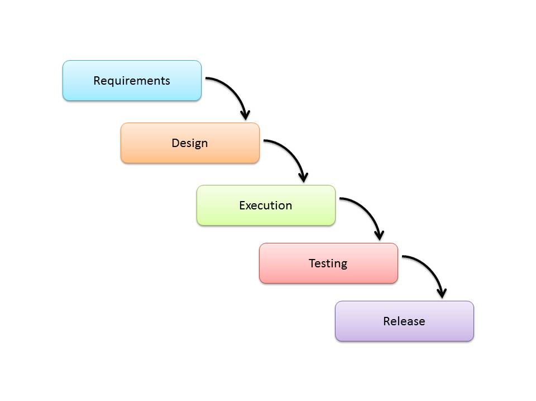

**Fig 3.1Waterfall Model**

##### 3.2 FUNCTIONAL REQUIREMENTS

The Functional Requirements of this research work include:

* The system should provide applicants easy to understand information about job vacancies.
* The system should be able to search for jobs based on the input of the user.
* The system should allow the company to access job seekers resumes.
* The system should be able to search for applicants based on the input by the company.

##### 3.3 NON-FUNCTIONAL REQUIREMENTS

The Non-Functional Requirements for the Research work include:

* **Speed**: The system should be able to provide quick results for the users based on the options selected.
* **Size**: The system should not take up a lot of the users systems’ Memory.
* **Ease of use**: The system should be easy to use with a clean user Interface.
* **Reliability**: The system should have very little down time and produce a small percentage of errors.
* **Robustness**: The system should be able to recover quickly and efficiently from failures.
* **Portability**: The System must be able to function properly on a wide range of devices.
* **Scalability**: The System must perform efficiently even as it grows in size.

### 3.5 SYSTEM DESIGN

### Use Case Diagram: The system has two actors, the admin and the general users who apply for job. Below is the diagram depicting the actions of these actors:

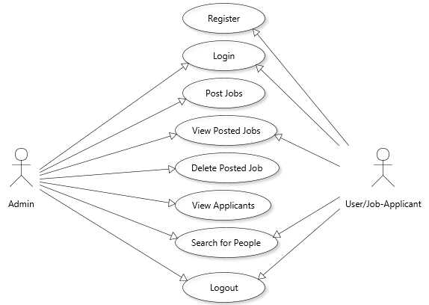

**Figure 3.2: Use-Case Diagram**

### 3.6 Database Design

### The application uses a non-relational database. Below is the screenshot of the database’s tables:

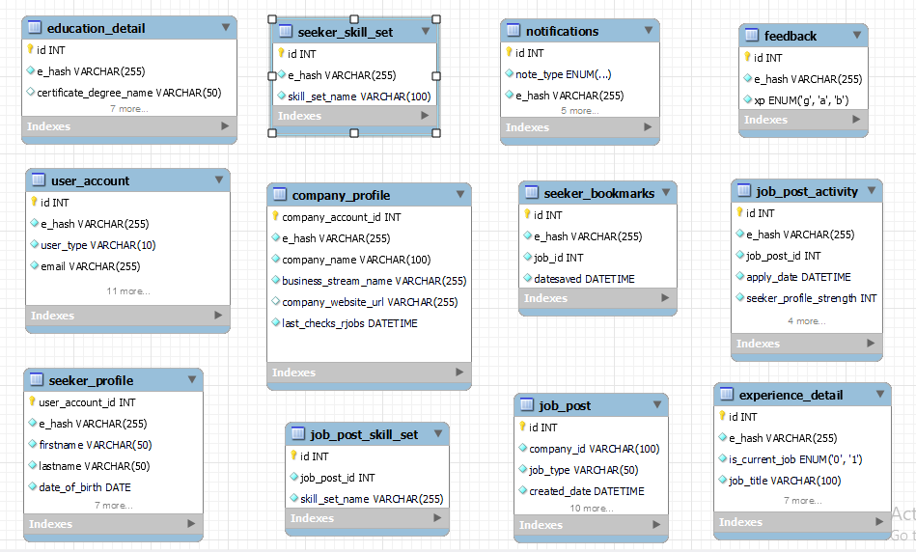

**Figure 3.3: Tables of the database**

**CHAPTER FOUR**

**SYSTEM IMPLEMENTATION**

### 4.0 INTRODUCTION

This chapter provides an insight on the decision of platform and programming languages, software and hardware requirements, and the modules and interfaces that were executed.

### 4.1 TECHNICAL TOOLS USED

The Tools used in developing the software are:

* **HTML:** Hyper-Text Markup Language, regularly alluded to as HTML, is the standard markup dialect used to make website pages. Alongside CSS, and JavaScript,
* **SQL**: MySQL was used for the database of the application.
* **PHP:** PHP was used for building the back-end of the application.

**4.2 SYSTEM TESTING**

|  |  |  |  |  |  |
| --- | --- | --- | --- | --- | --- |
| TEST ID | FUNCTION | DESCRIPTION | EXPECTED RESULT | ACTUAL RESULT | STATUS |
| 1 | User navigate to signup page | User tries to navigate to the signup/registration page | User navigated to the signup page | User was able to navigate to the signup page | Successful |
| 2 | New user registration | New user tries to register into the system | New user registered into the system | New user registered into the system | Successful |
| 3 | Registered user Login | Registered user  tries to log into the system | Registered user logged into the system | Registered user was able to log into the system | Successful |
| 5 | Upload a job | Admin tries to upload a job | Admin uploaded a job | The admin was able to upload a job. | Successful |
| 6 | View Posted Jobs | Admin and User try to view posted jobs | Admin and User viewed posted jobs | The admin/user were able to view posted jobs. | Successful |

### 4.3 SYSTEM REQUIREMENTS

**Hardware Requirements**

1. A minimum of 1GB ram is required to run the application.

**Software Requirements**

**1.** Xamp 5.6.40 or later versions is required to run the application

### 4.3 INTERFACES AND MODULES

This section gives a pictorial view of the various modules, sub modules and interfaces of the web application.

#### **Landing Page**

This is the first page that is shown anytime the site is accessed. It states the different services offered by the application.

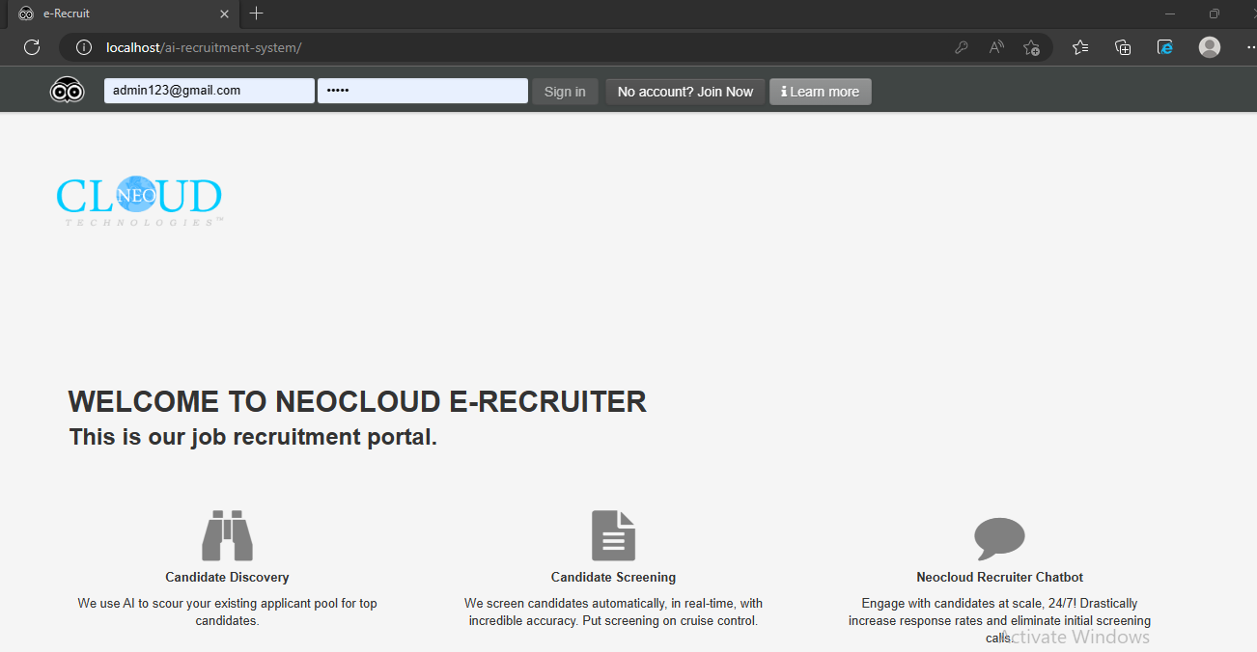

**Figure 4.1: The Landing/Index page**.

#### **Login Page**

At this module the users of the platform login to their accounts using their respective email and password. A couple of thing would happen on this page.

* The user is verified if he has an account with us.

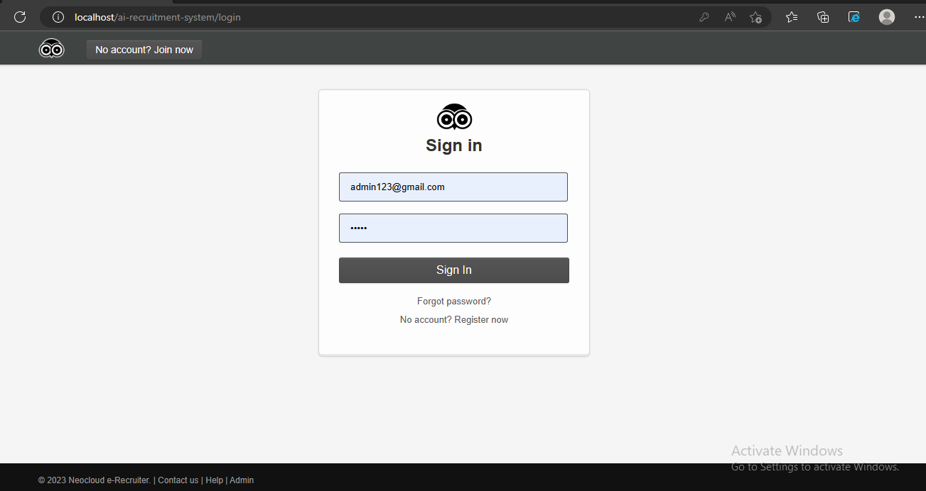

#### **Figure 4.2: Login Page**

**User Homepage**

This is the page which the user is redirected to after opening a an account and has been successfully authenticated by the login platform for the application. This page displays the most recent jobs which have been posted.

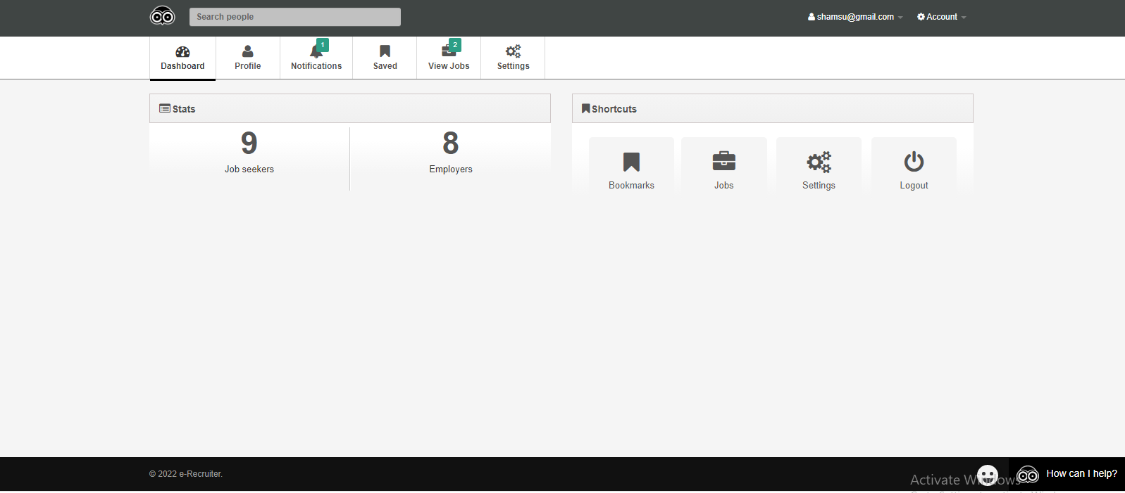

**Figure 4.3: Candidate homepage.**

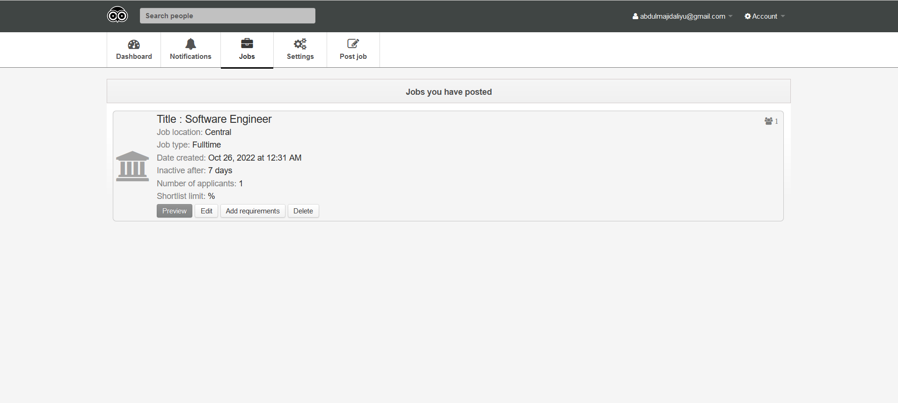

**Figure 4.4: Homepage showing the most recent jobs posted.**

**Posting Job Page**

This page is where the jobs that are viewed by the candidate are created, this page can only be accessed by the admin.

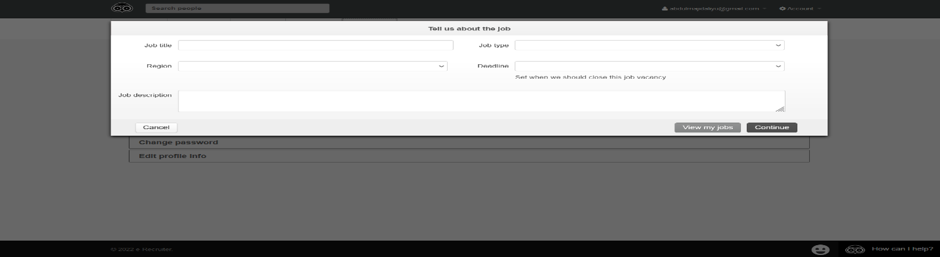

**Figure 4.5: Post a job page.**

##### Registration Page

This page is where the users register.

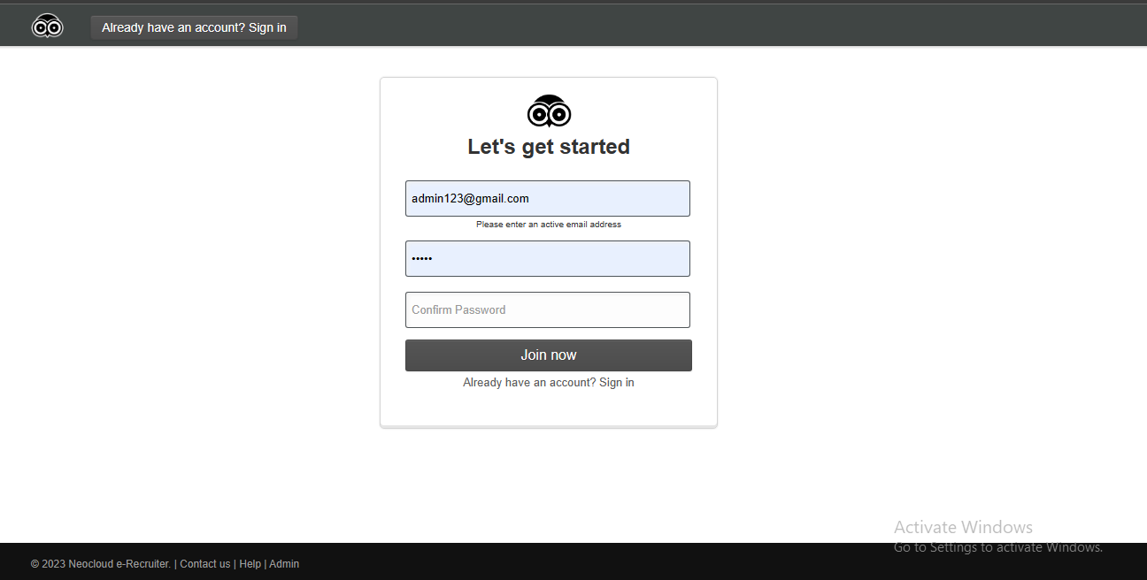

**Figure 4.6: Registration page**

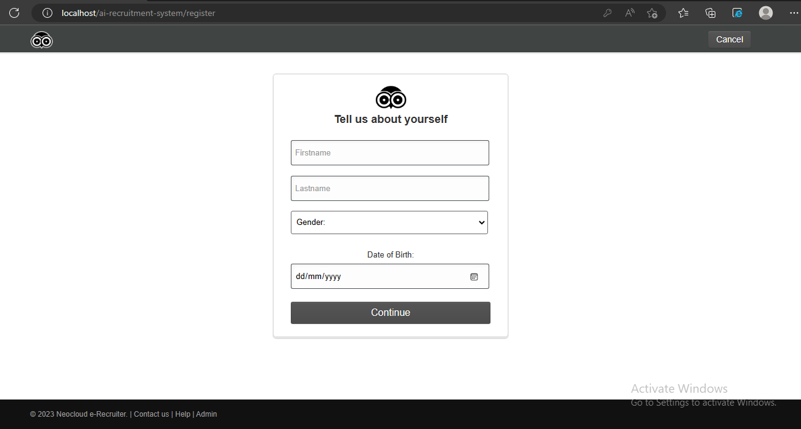

**Figure 4.7: Registration continued/Tell us more about you page**

##### Other Modules

Modules which were also added to the platform include the following: the jobs page, the candidate profile page, the profile update page, the search result page, the upload page, the add experience/education page.

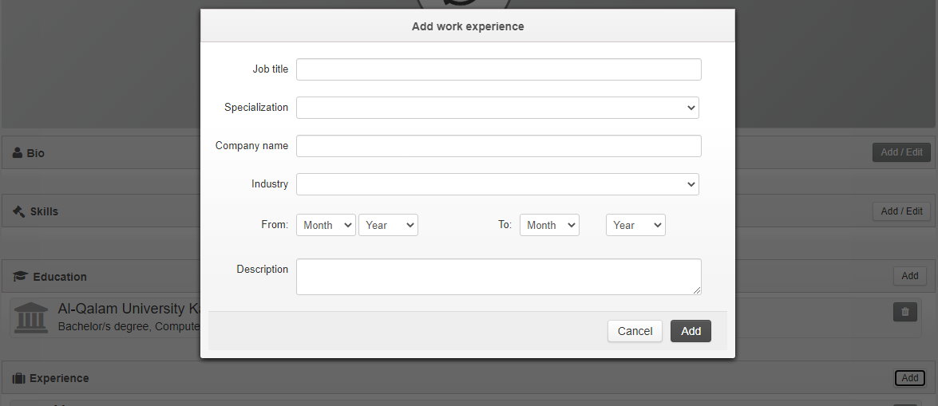

#### **Figure 4.8: Add experience/**education

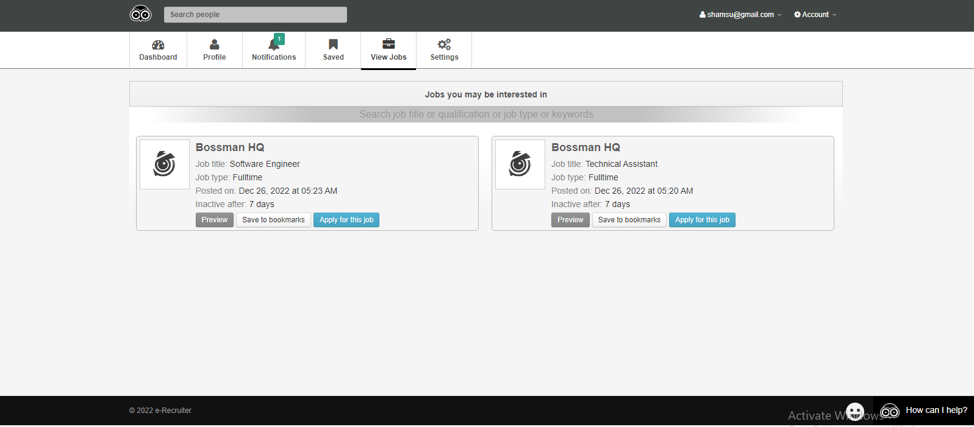

#### **Figure 4.9: Jobs page**

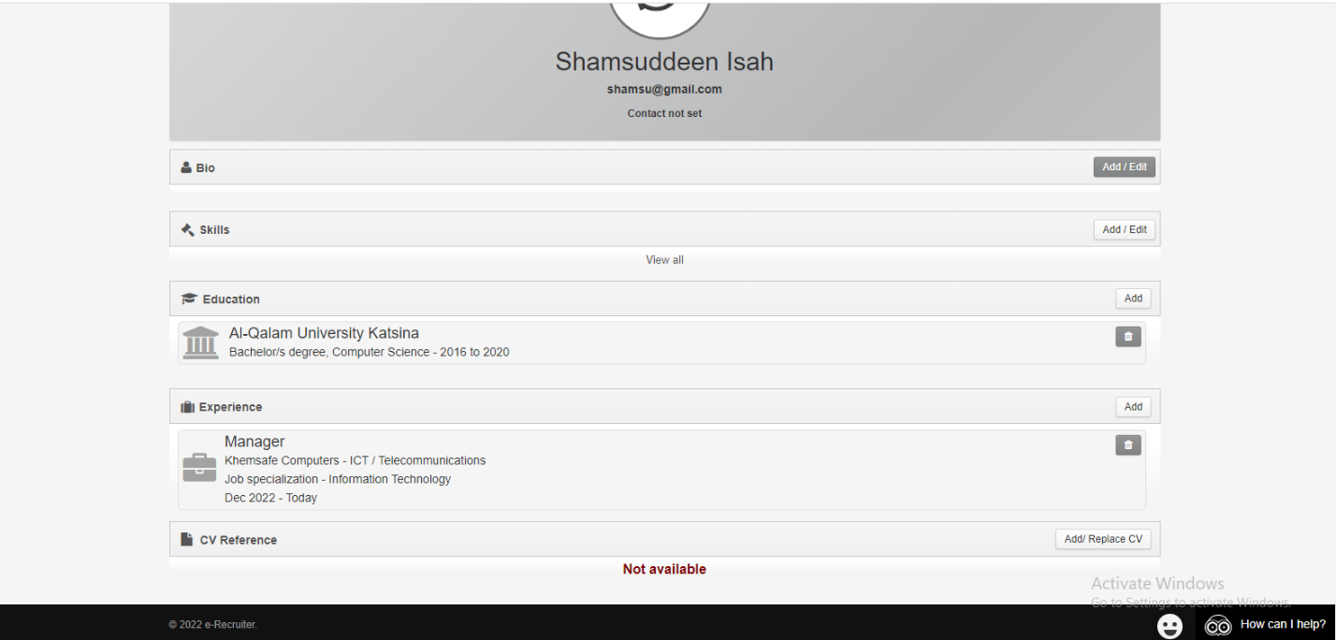

#### **Figure 4.10: Candidate profile page**

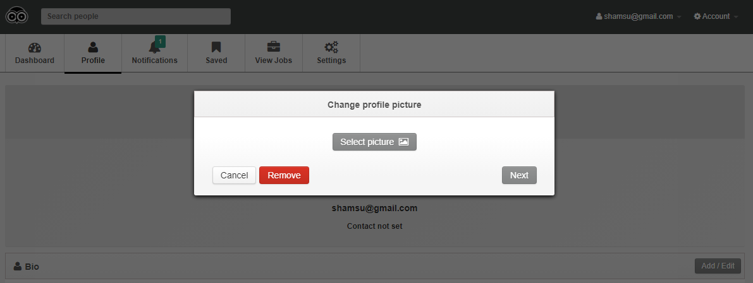

**Figure 4.11: Update profile photo**



**Figure 4.12 CV Upload page**

**CHAPTER FIVE**

**SUMMARY, CONCLUSION AND RECOMMENDATION**

**5.0 INTRODUCTION**

This chapter summarizes the contributions of this work and highlights some areas for future

study.

**5.1 SUMMARY**

This project “Design and Implementation of a Recruitment Management System “e-Recruiter” is the development of an e-recruitment software to help an organization manage its recruitment processes. implementation was done in php while also using html, JavaScript and CSS for visual appeal. MySQL was used for the database backend program. A review of history, growth and societal effect of existing e-recruitment systems are provided.

**5.2 CONCLUSION**

E-recruitment otherwise known as online recruitment is a time and money saving platform which the company can use in order to reduce cost of recruitment for itself. This project is targeted towards the easy and efficient job search. “e-Recruiter” E-recruitment can be improved further by creating modules or functionalities which support the testing of candidate and also referral of such candidates to companies based on their scores and their ranking on the recruitment platform.

**5.3 RECOMMENDATIONS AND FUTURE WORKS**

The field of e-recruitment still has a lot of issues that are not completely resolved. Recommendations for the further improvement of this project includes:

* Notifications on new job posted by email or SMS.
* Creation of test to validate the skills of candidates.
* Account verification via email notification.

**REFERRENCE**

Du Plessis A. J. (2007). Change, organizational development and culture: human resource

management’s role in a future South Africa. *International Review of Business Research Papers*, 3(1):1-10.

Dysart J. (2006). Electronic recruiting. *American School Board Journal*, 193(7):27-29.

Furness V. (2007). Measure for measure. *Personnel Today*. 3(1):53-54.

Härtel, Fujimoto, Strybosch, Fitzpatrick. (2007). *Human resource management.*

*Transforming theory into practice*. Australia: Pearson Education.

Marzulli T. (2002). Using internet technology to streamline healthcare recruiting. *Health*

*Financial Management*, 56(6):62-64.

May J. (2006). Effective hiring processes will keep your company in motion. *Caribbean*

*Business*, 34(11):9.

Nel P.S., Van Dyk, Haasbroek G.D., Schultz H.B., Sono T. & Werner A. (2004). *Human*

*Resources Management*. 6th edition. Cape Town: Oxford University Press.

Rudman R. (2005). *Human Resources Management in New Zealand*. 4th edition. Auckland. Prentice Hall.

Schoen L. (2002). E-technology streamlines staffing. *Offshore*, 62(12):64.

Sommerville I. (2011). *Software engineering*. Pearson.

Nike’s. (2005). Nike’s successful e-recruitment. *Strategic HR Review,* 4(3): 4.

Trapp R. (2002). Bargain hunt. *People Management*, 8:25, 32-35.

Turban D. B., & Keon T. L. (1993). Organizational attractiveness: An interactionist

perspective. *Journal of Applied Psychology*, *78*(2):184.

Crunch-Base. (n.d). *neo-cloud-technologies*. Retrieved January 28, 2023, from https://www.crunchbase.com/organization/neo-cloud-technologies

Neocloud. (n.d). *about-ICT-Training-Cyber-Security-Corporate-Training-Abuja*. Retrieved January 27, 2023, from Neocloud: https://www.techneo.ng/about-ICT-Training-Cyber-Security-Corporate-Training-Abuja